

**Experiment No: 15**

**Name of the Experiment : Implementation of Priority encoder.**

**Course Title: *Digital Logic Design Lab***

**Course Code: *CSE-206***

**Submitted to : Syed Ahsanul Kabir**

**Submitted by : Mahadi Hasan Shifat**

**Student ID : 130202047**

**Submission date : 16/04/2014**

***Name of Experiment :***

**Implementation of**  **Priority encoder** .

***Objective :***

The ultimate goal of this experiment is to learn more of the VHDL and how to create the priority encoder with it . we will learn how to implement the design of priority encoder and test it.

***Theory of Decoder :***

To begin this section a clear picture of designing a priority encoder . Then , A priority encoder is a combinational circuit that implements a priority function . As mentioned in the preceding paragraph , the operation of priority is such that if two or more inputs are equal to 1 at the same time the input having the highest priority takes precedence .Finally, we will create a test on our design and show the assign pins for input and output .

***Truth table of priority encoder :***

|  |  |  |  |  |  |  |
| --- | --- | --- | --- | --- | --- | --- |
| **Input** | | | | **0utput** | | |
| **D0** | **D1** | **D2** | **D3** | **X** | **Y** | **Z** |
| **0** | 0 | 0 | 0 | X | X | 0 |
| **1** | 0 | 0 | 0 | 0 | 0 | 1 |
| **X** | 1 | 0 | 0 | 0 | 1 | 1 |
| **X** | X | 1 | 0 | 1 | 0 | 1 |
| **X** | X | X | 1 | 1 | 1 | 1 |

**X=D2+D3**

|  |  |  |  |  |  |  |  |  |  |
| --- | --- | --- | --- | --- | --- | --- | --- | --- | --- |
|  | **00** | **10** | | **11** | | | **01** | | |
| **00** | X |  | **1** |  | **1** |  | | **1** |  | |
| **10** | **0** |  | **1** |  | **1** |  | | **1** |  | |
| **11** | **0** |  | **1** |  | **1** |  | | **1** |  | |
| **01** | **0** |  | **1** |  | **1** |  | | **1** |  | |

**Y= D3 +D1D2’**

|  |  |  |  |  |  |  |  |  |
| --- | --- | --- | --- | --- | --- | --- | --- | --- |
|  | 00 | | **10** | | | **11** | | **01** |
| **00** | X | |  | 1 | | 1 |  | 0 |
| **10** |  | 1 |  | 1 |  | 1 |  | 0 |
| **11** |  | 1 |  | 1 |  | 1 |  | 0 |
| **01** | 0 | |  | 1 | | 1 |  | 0 |

***Circuit diagram :***

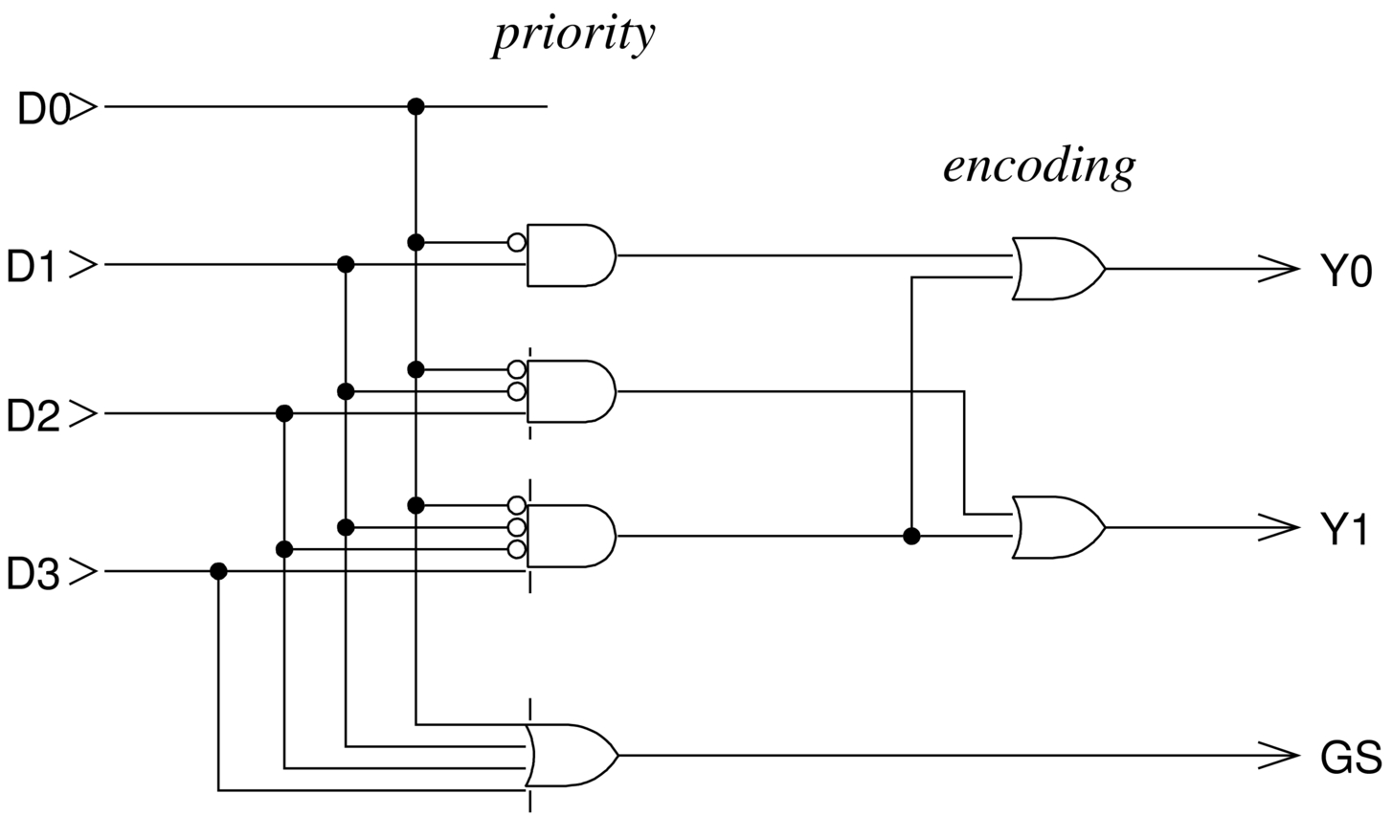

***Hardware Requirement :***

a. Equipment’s - Digital IC Trainer Kit

b. Discrete Components -

74LS04 Quad 2-Input NOT gate

74LS08 Quad 2-Input AND gate

74LS32 Quad 2-Input OR gate

***Pin configure :***

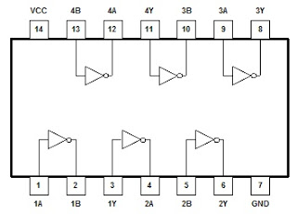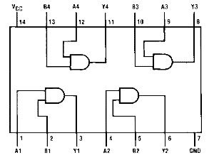

***Result :***

|  |  |  |  |  |  |  |
| --- | --- | --- | --- | --- | --- | --- |
| **Input** | | | | **0utput** | | |
| **D0** | ***D1*** | ***D2*** | ***D3*** | ***X*** | ***Y*** | ***Z*** |
| **0** | 0 | 0 | 0 | X | X | 0ff |
| **1** | 0 | 0 | 0 | 0ff | 0ff | **On** |
| **X** | 1 | 0 | 0 | 0ff | **on** | **on** |
| **X** | X | 1 | 0 | **on** | 0ff | **On** |
| **X** | X | X | 1 | **on** | **On** | **on** |

***Precaution :***

1. All The connections must be made correctly and tightly.

2. handle the ic’s carefully.

3.check the connection once again before switching on the Digital Trainer KIT

4. switch of the Trainer KIT after performing the Experiment.

***Discussion:***

1. We are three members in our group.
2. We use those IC’s first time, so it is little bit difficult to find the correct IC with its individual numbers. Example: 7432,7404,7411.
3. Our instructor shows us, how to hold those IC correctly and the pin configuration. Example: 14 no pin for Vcc, 7 no pin for ground.
4. Then we placed those IC to the Bread board and connect it with power supply.
5. Finally we did that experiment correctly and got the correct result.